AI-ASSISTED-CODING

LAB-TEST -2

2403A5125

BATCH-11

SUBGROUP A:

Task : A.1— [S18A1] Compute per-probe average from logs (AI completion)

QUESTION :

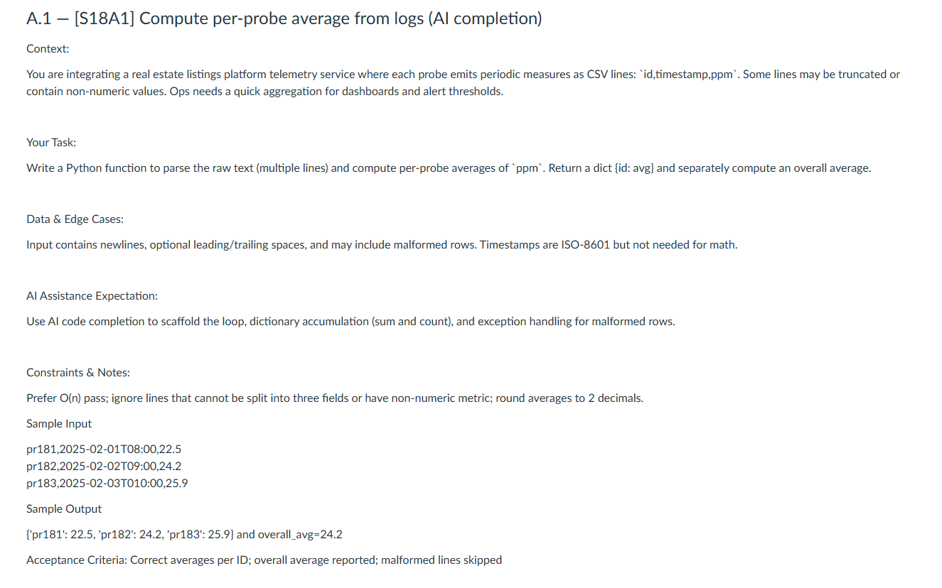

PROMPT :

#Write a Python function to parse the raw text (multiple lines) and compute per-probe averages of `ppm`. Return a dict {id: avg} and separately compute an overall average of `ppm` across all probes and timestamps.

# sample input : pr181,2025-0201T08:00,22.5pr182,2025-02-02T09:00,24.2pr183,2025-02-03T010:00,25.9

CODE :

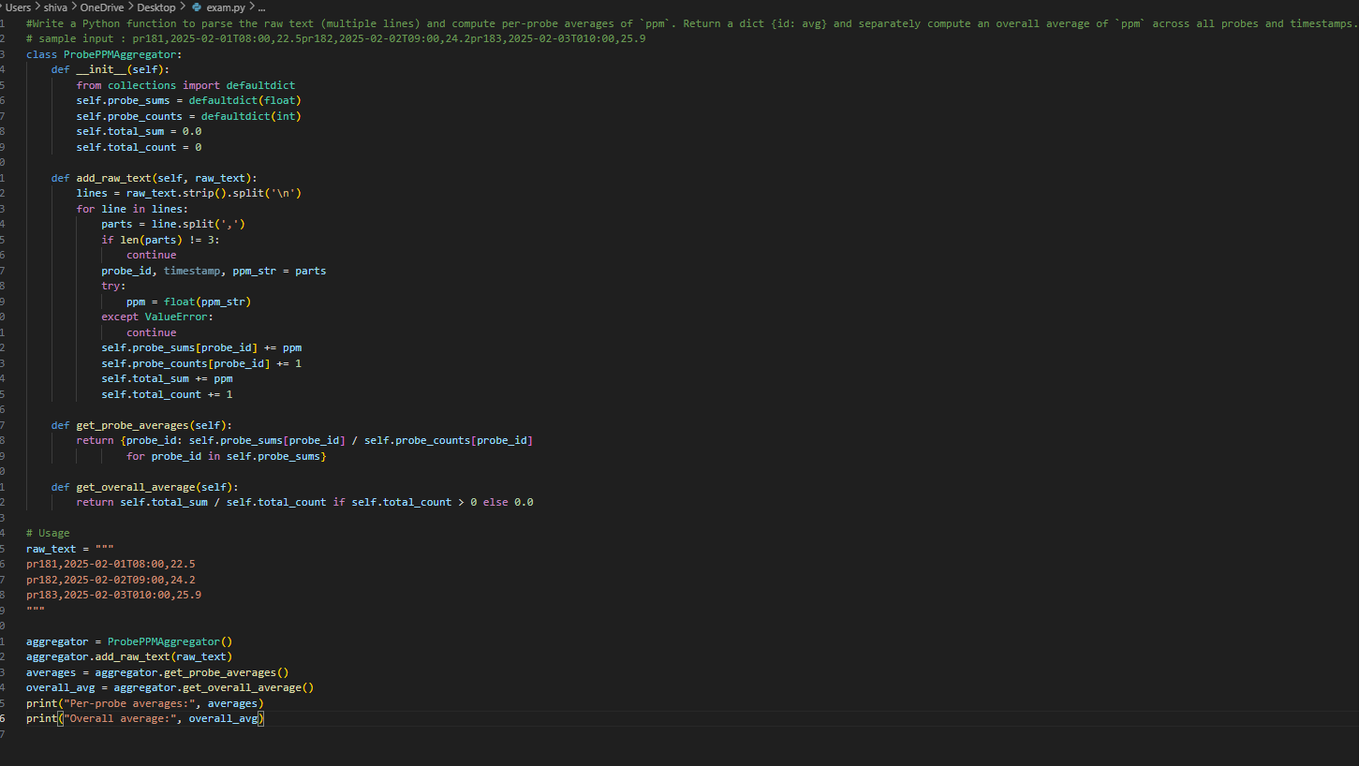

OUTPUT :

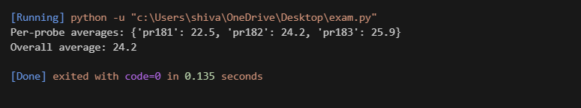

Task : A.2 — [S18A2] Implement ListingWindow with add/remove/summary (AI completion)

QUESTION :

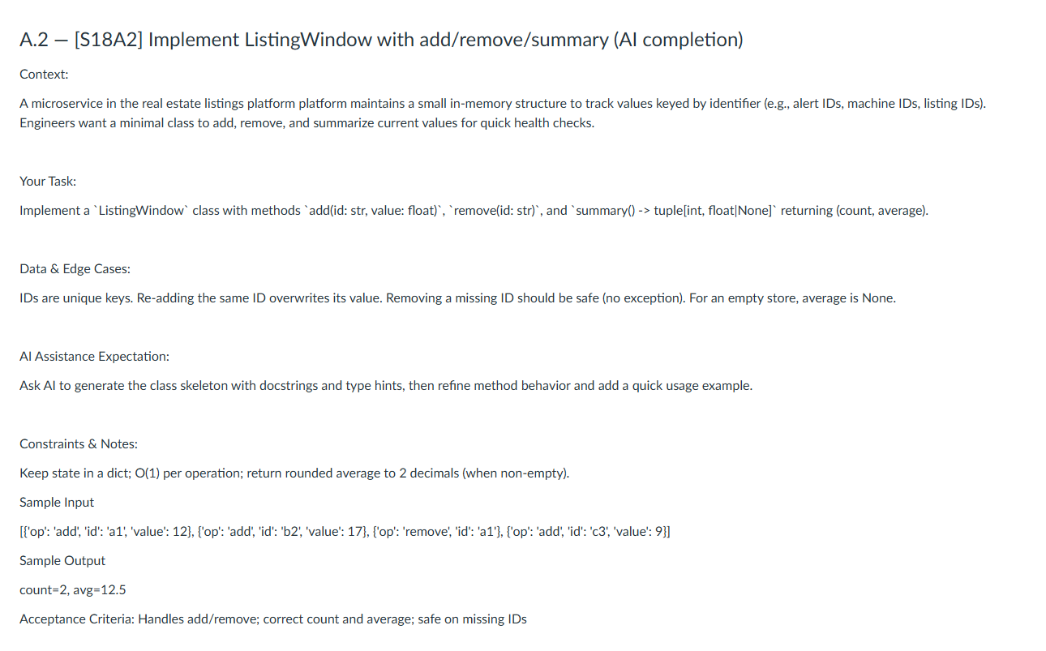

PROMPT :

#Implement a `ListingWindow` class with methods `add(id: str, value: float)`, `remove(id: str)`, and `summary() -> tuple[int, float|None]` returning (count, average).

# The class should maintain a sliding window of the last N added values, where N is specified at initialization.

Code :

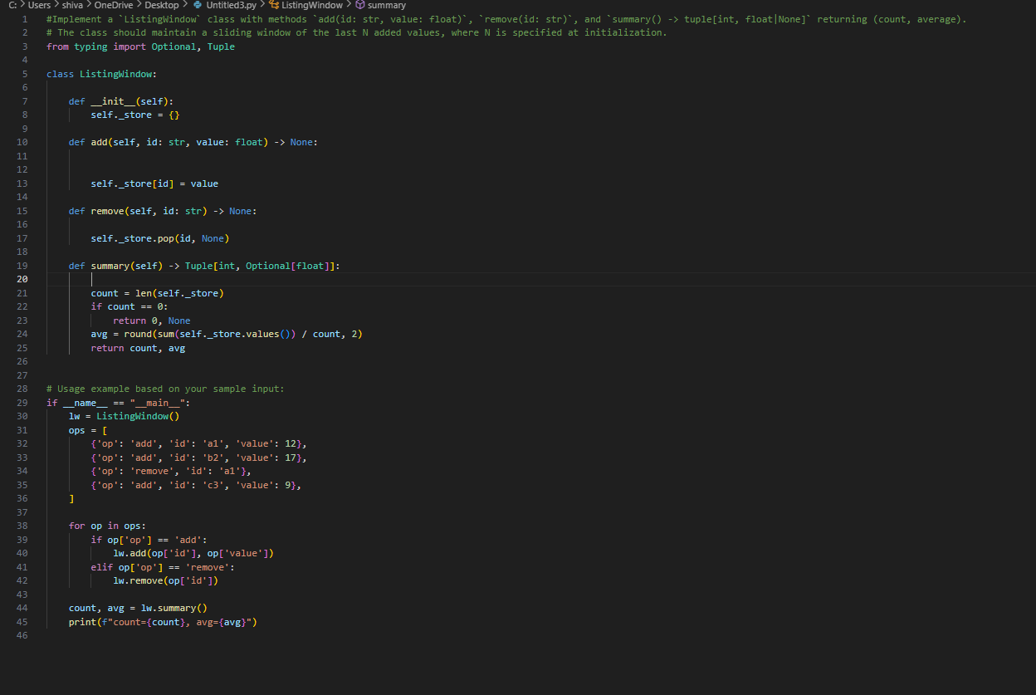

OUTPUT :

